CN Lab Report – Week 8

PES1201800366

Aditeya Baral

**1. IPv4 Addressing and Topology Creation**

* The following topology is created and deployed on **ClayNet**.

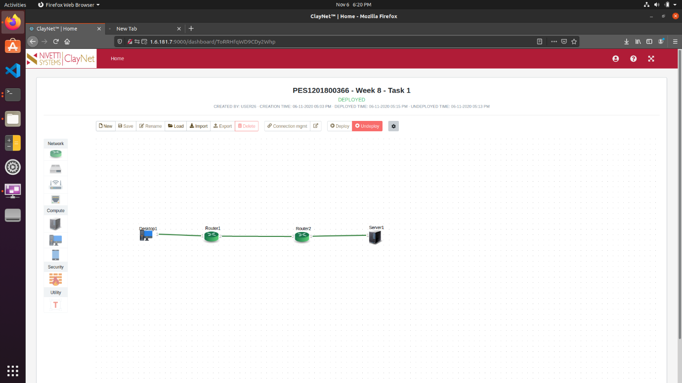

* The configuration of all the end-system devices is shown below.

|  |  |  |
| --- | --- | --- |
| **End System** | **IP Address** | **Gateway** |
| Desktop1 | 10.10.10.2/24 | 10.10.10.1 |
| Server1 | 30.30.30.2/24 | 30.30.30.1 |

* Similarly, the routers are configured in the same manner.

|  |  |  |
| --- | --- | --- |
| **Router** | **Interface Number (port)** | **IP Address** |
| Router1 | 1 | 10.10.10.1/24 |
| Router1 | 2 | 20.20.20.1/24 |
| Router2 | 1 | 30.30.30.1/24 |
| Router2 | 2 | 20.20.20.2/24 |

**2. Ping Command**

* From Desktop1, a **ping** command is made to Server1.
* However, this ping command fails because the routing table entries have not been configured yet for Router1 and Router2.
* We obtain a **Destination Host Unreachable** status.

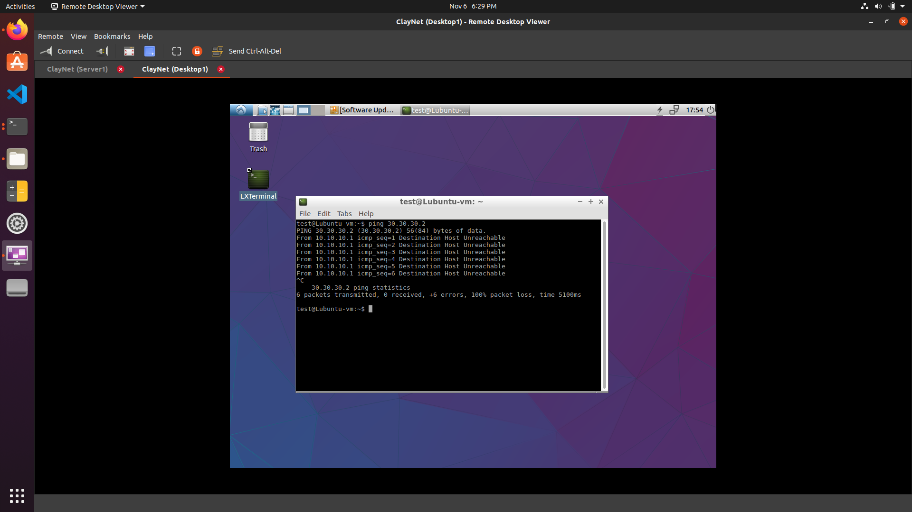

**3. Configuration of Routing Table Entries**

**3.1 Router 1**

* The Routing Table entries for Router 1 are configured using the below commands in the console window.

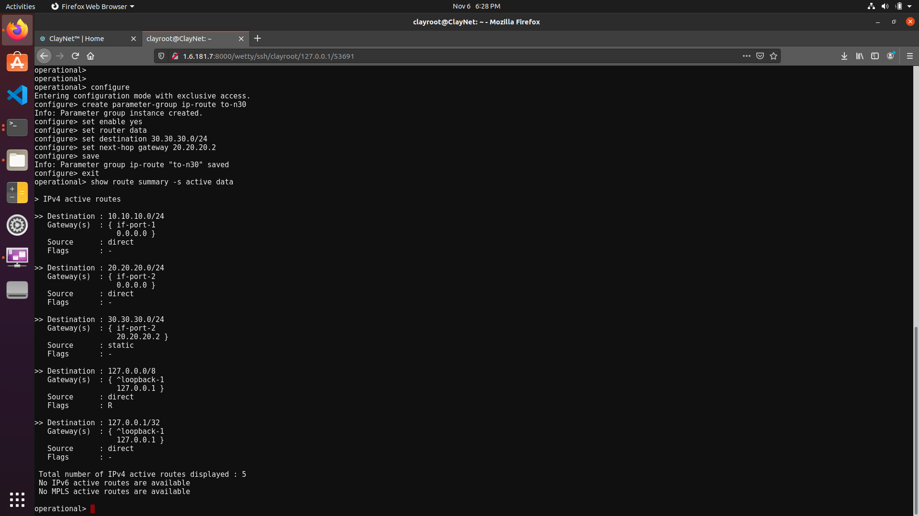

* The resulting Routing Table Entry is shown below.



**3.1 Router 2**

* The Routing Table entries for Router 2 are configured using the below commands in the console window.

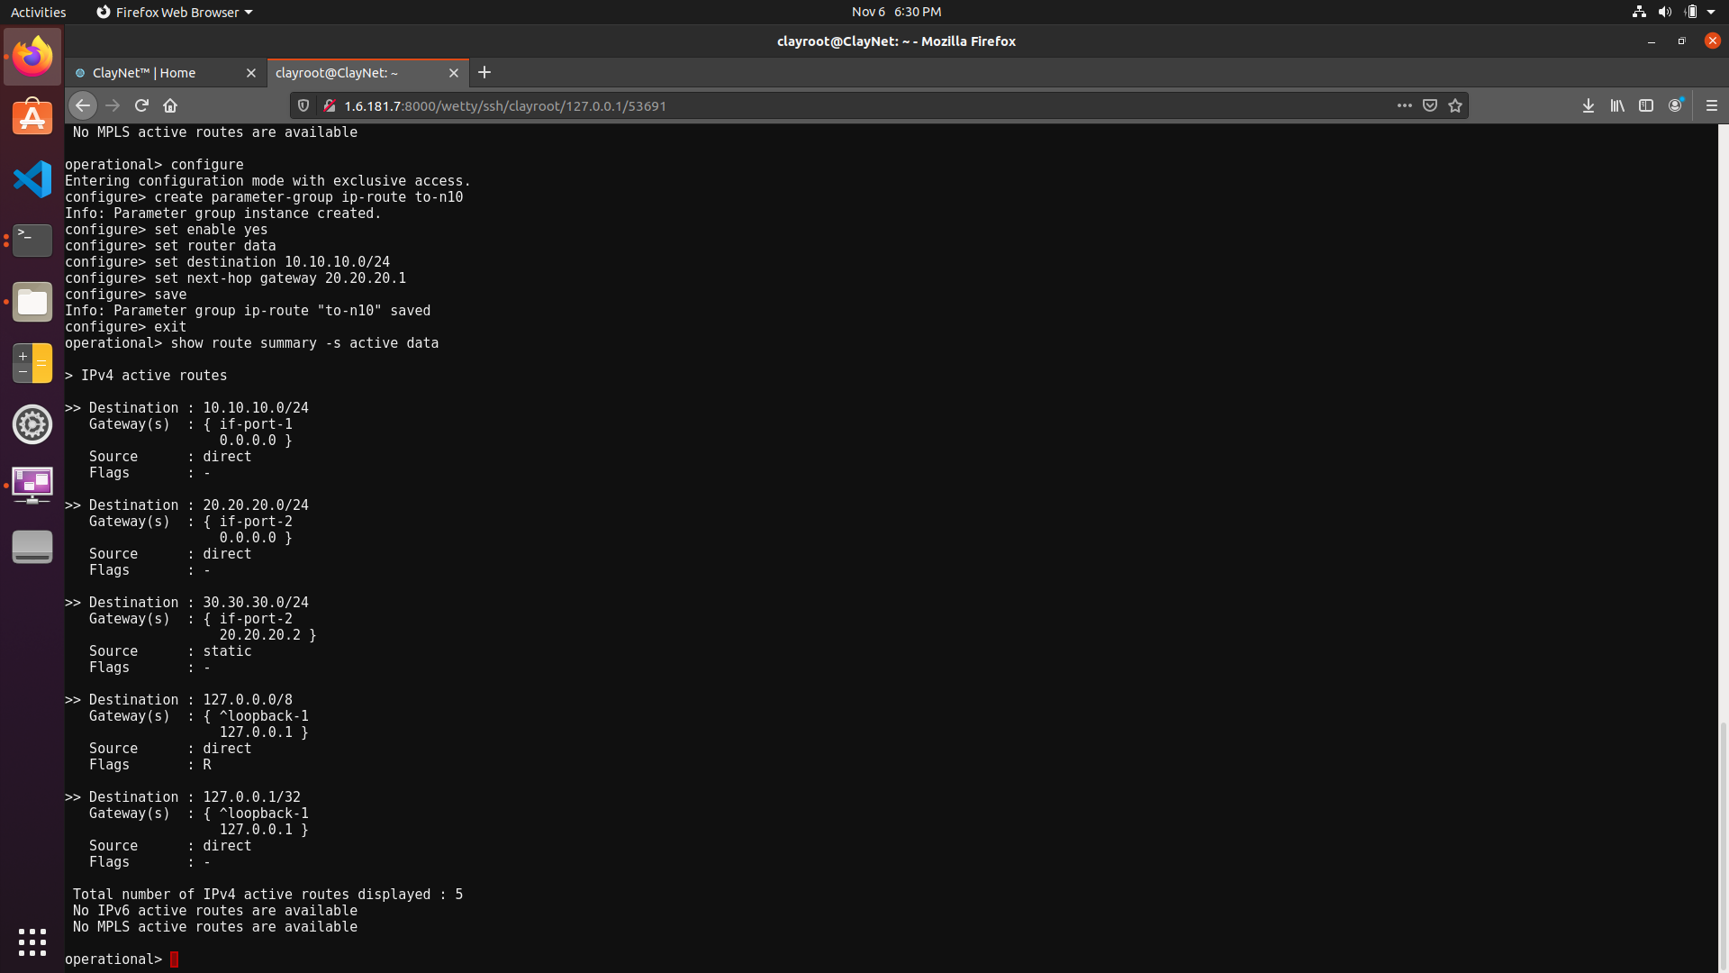

* The resulting Routing Table Entry is shown below.

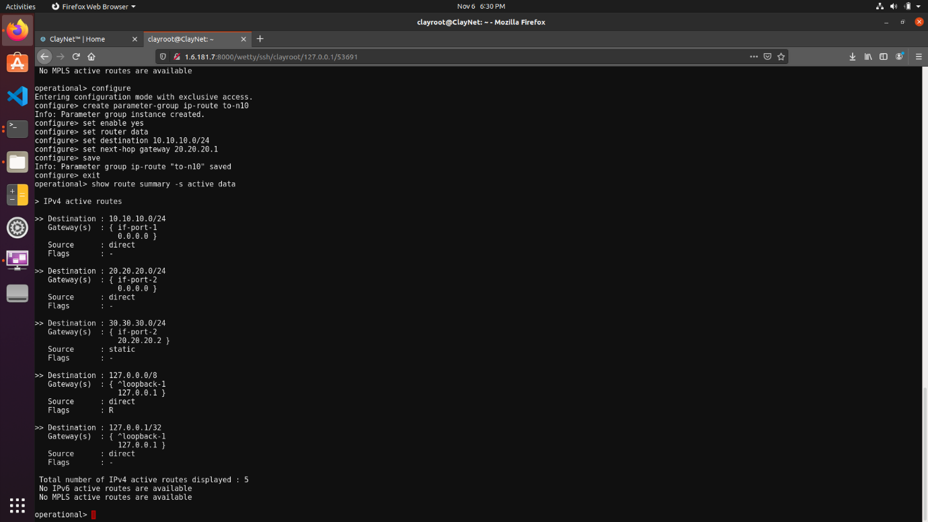

**4. Observations**

* Desktop1 and Server1 are now reachable from each other.
* To verify this, the **ping** command is again used to ICMP request packets to the other.
* Since there are 2 hops between the systems, the TTL value is decremented by 2. Hence the value is decremented from its default value of 64 to 62.

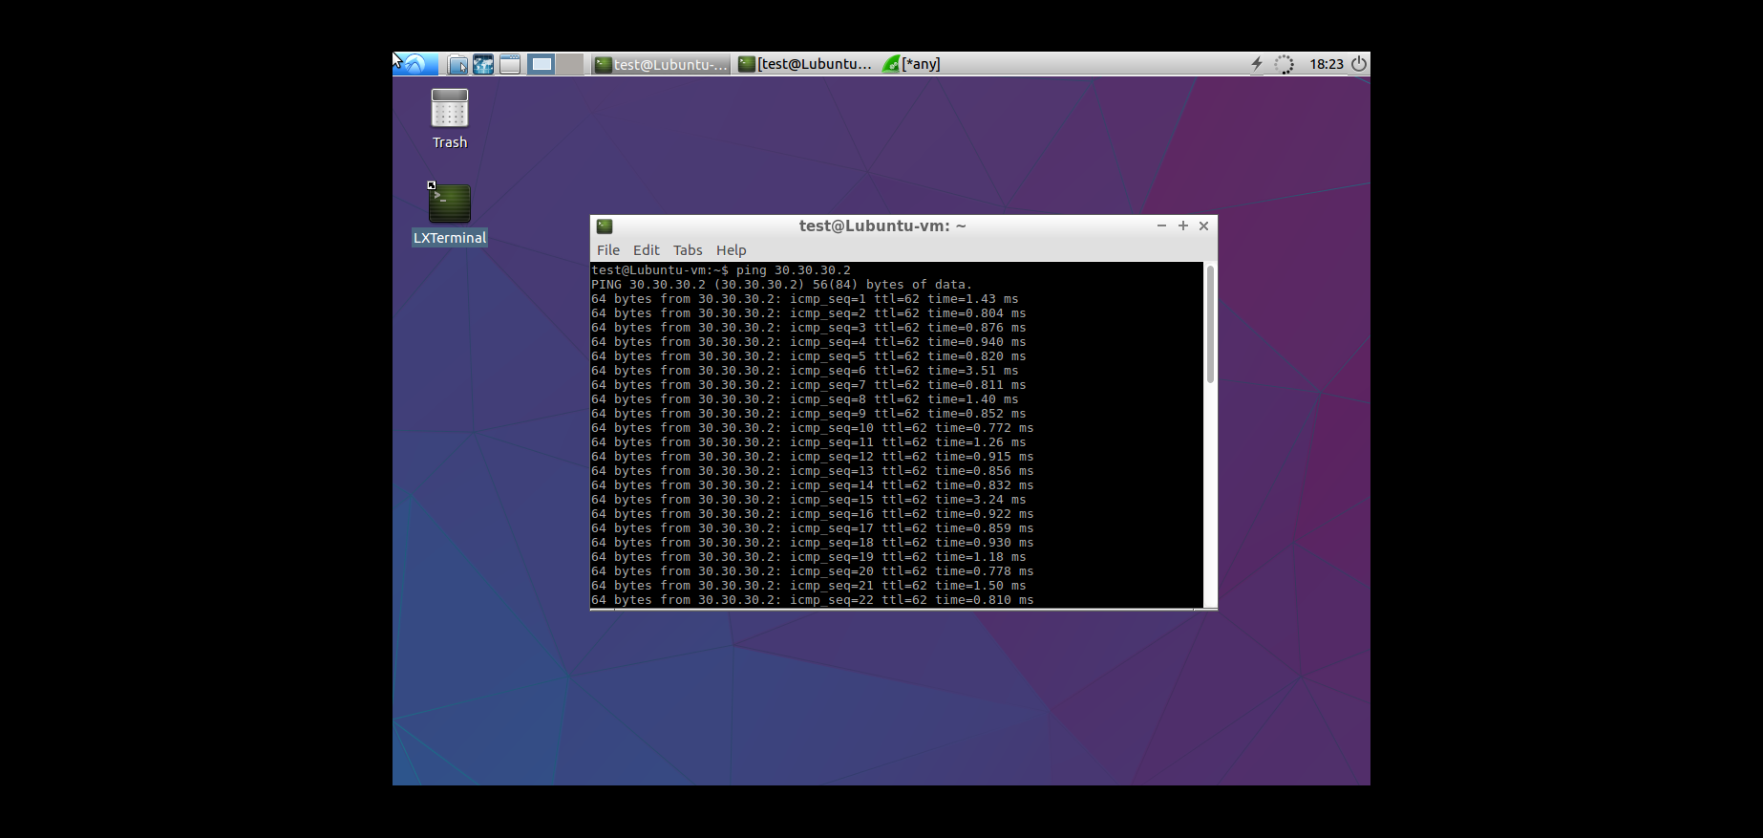

* The following Wireshark Packet Capture shows ICMP request packets being sent from Desktop1 to Server1.

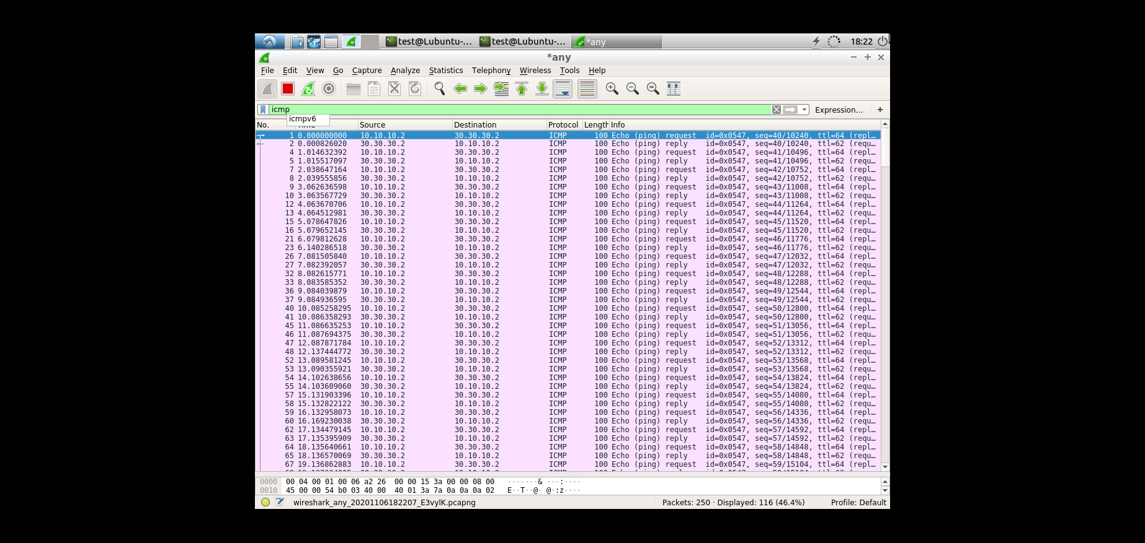

* The following screenshot displays the outcome of the traceroute command from Desktop1 to Server1.

